AP English Language & Composition Summer Assignment 2025-2026

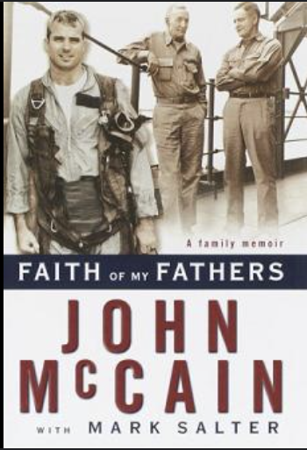
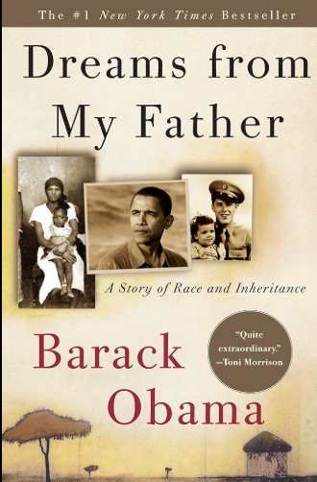

St. John’s AP Language & Composition is a course that will develop your ability to effectively understand and craft arguments. For our first assignment, you will read two memoirs:

- Barack Obama’s Dreams from My Father: A Story of Race and Inheritance (first published in 1995)

- John McCain and Mark Salter’s Faith of My Fathers: A Family Memoir (first published in 1999)

Take note of passages you find interesting, aspects that seem to shape the writer’s character, and moments that help you understand the role of fatherhood within the memoir. Your annotations should reflect an attention to detail: language choices, sentence style, syntax, voice, and so forth.

As you read, consider the following questions and be able to discuss in class:

- Both memoirs feature often-absent fathers, yet those fathers become a major force in the writers’ lives. Considering how both Obama’s and McCain’s fathers influence them in his life.
- Obama’s memoir was published as he prepared to run for the Illinois state senate but long before he ran for president, and McCain’s was published the year before he ran for president. Each memoir plays an important role in contributing to the writer’s persona, meaning his character, attributes, or traits that he chooses to present to the world. Think about how and why the writer—Obama and McCain—shape his persona.

Upon returning to school at the end of summer, be prepared to show detailed annotations of the book to your teacher.

