AP English Literature and Composition Summer Reading

A major focus of AP English Literature and Composition is judging whether a work possesses literary merit and being able to identify and analyze how. An important skill for this course is evaluation. You can read. You can think about what you’ve read. You can write about what you think. Now we need to really think about how we make judgements about what we read. So, actively consider how you evaluate each text.

Your summer reading assignment is to read and think seriously about THREE novels of literary merit.
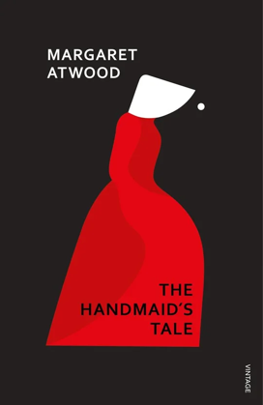
- As your first text, please read The Handmaid’s Tale by Margaret Atwood. As you read, annotate and keep track of key passages regarding the following priorities:
- What is the author’s stance or criticism regarding the sources and nature of oppression?
- How is power enforced or inflicted, and what are its tangible and intangible consequences?
- To what extent is individual agency (think: autonomy, freedom, independence, rebellion) successfully enacted or negotiated by oppressed individuals?
- What role do secret behaviors and information play in the defiance or enforcement of power?
- What is the impact of oppression on the oppressor?
- Considering the world beyond the text (whether the context within which it was written or the context in which you are reading), what broader social criticisms, themes, or warnings arise as meaningful and relevant?

- As your second text, choose from the following list:

Never Let Me Go by Kazuo Ishiguro
Station Eleven by Emily St. John Mandel
Parable of the Sower by Octavia E. Butler

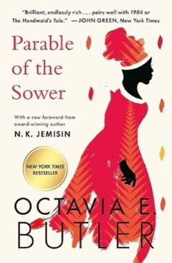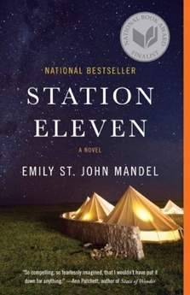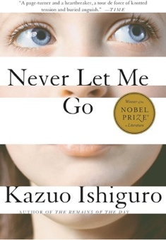

While you read consider: What is the setting of this story? Who are the primary characters? What are their motivations for action? What types of conflicts are they involved in? How much times does the plot span? How are the events of the narrative organized? How is the dystopian world created? Considering the world beyond the text (whether the context within which it was written or the context in which you are reading), what broader social criticisms, themes, or warnings arise as meaningful and relevant?

After reading the two texts, consider the following questions: Which text has more literary merit? Which story makes “the audience want to know what happens next”? How does this story do that? Consider aspects like genre, focus, conflict, character development, narrative perspective, verisimilitude, organization, universality like themes or archetypes, details like symbols, motifs, etc.

In the first two weeks of school, be prepared for written assessments and formal (graded) discussions of your work on the two texts you read.

- Choose a third text of your choice. Choose something you are interested in or that you’ve been wanting to read for a while. You are welcome to choose any text you want and read just for the joy of reading. Then, create a Goodreads-style review of the book and make a mini-poster for the text on a piece of paper or on a drawing app. Include your rating of the text, a short description of the plot that someone might find on the back of the book cover, and the author and title of the text. Fill the entire page, use color, add decorations on the page that connect to the text. Be creative and have fun with the assignment.

If you have any questions, please contact Ms. Paluch at cpaluch@stjohnschs.org

